**→ MALARIAL CELL CLASSIFICATION USING CNN :**

**(1) Define library’s :**

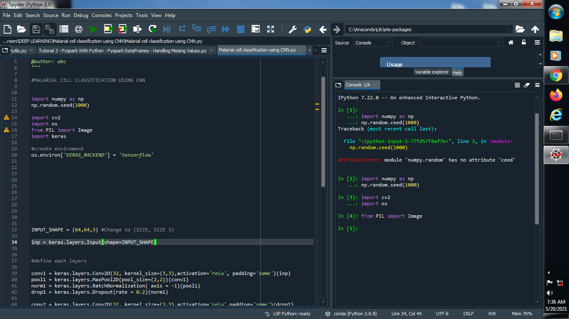

**(2) Create an environment :**

